
United Women of Rockland
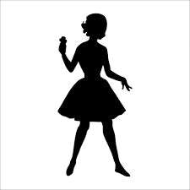
Pin-Up Contest
Rules

Saturday, September 8, 2018
Hudson Valley Harley Davidson
33 NY-304, Nanuet, NY 10954

Pin-up attire only please! Keep it classy not trashy.
Make sure you are staying with the Pin-Up theme of the 1940’s to early 1960’s.
1) All contestants MUST be 18 and over. This is a family event first and foremost! Please no stripping, nudity or foul language.
2) Each contestant is encouraged to submit a photo that will be displayed in various forms for show promotion. You may submit the photo in advance by emailing it to ktillette@gmail.com or unitedwomenofrocklandinc@gmail.com with your name and contact info. Photos may not contain nudity.
3) It is the contestant’s responsibility to ensure no images you submit constitute copyright infringement and that they can be used without issue on the United Women of Rockland website and any/all related social networks. Please acknowledge your photographer, MUA, and anyone else that had an important part in the photo, and if necessary please provide release form as needed.
4) Contestants must be available immediately following the contest for winner/group photos.
5) Your image (as a contestant or title winner) can and will be used in promotional materials in association with United Women of Rockland and their affiliates.
6) Rules and judging criteria are subject to change at the discretion of United Women of Rockland.
7) Participants are encouraged to fill out a contest registration form and either mail or email form to United Women of Rockland. PO Box 105, Stony Point, NY 10980 prior to the event. ktillette@gmail.com or unitedwomenofrocklandinc@gmail.com Your ID will be needed day of contest.
9) Judging will be based on Authenticity, Originality, Overall Styling Presentation, Crowd Appeal, Stage Presence and other intangibles. There will be two categories
10) UWoR reserves the right to refuse, without notice, any entries due to misconduct or dress code violation.
11) Check in is between Noon – 1PM. 1:30 on stage introductions with Casual outfit. 3:00 on stage for Freestyle Outfit and winner announcement.
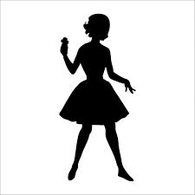
United Women of Rockland
Pin-Up Contest
Registration

Saturday, September 8, 2018

Contestant’s Name: _____________________________________

Pin-Up/Stage Name: ____________________________________

Address: ______________________________________________

______________________________________________

Cell Phone: ____________________________________________

Email: ________________________________________________

Date of Birth: __________________________________________

Any interesting facts you would like us to mention during the contest: _______________________________________________
________________________________________________________________________________________________________________________________________________________________________________________________________________________________________________________________________________________________________________________________________________________________________________________________________________________________________________________________________________________________________________________________________________________________________________________________________________________________________________________________________________________________________________________________________________________________________________________________________________________

Sign: __________________________________________ Date: __________________
Either mail or email form to United Women of Rockland. PO Box 105, Stony Point, NY 10980 prior to the event. ktillette@gmail.com or unitedwomenofrocklandinc@gmail.com

